**Description:**

OSMI (Open Source Metal Illness) performs survey every year to measure the attitude towards mental health in the technology workplace and to discover the frequency of the mental illness among the tech workers. It is a non-profitable corporation dedicated towards raising awareness, educating, and providing resources to support mental illness in tech and open source communities. The dataset contains the survey taken by employees/employers across the world (mainly US) from 2014 to starting of 2016. There are around 2600 employee surveys with 29 questions in each survey. Discovering the mental issues and measures taken by the companies towards maintaining employee’s health has become very important from the past few years due to the increasing work pressure across several working sectors of which tech companies are major contributors.

**Source:** <https://osmihelp.org/research> and <https://www.kaggle.com/datasets>

**Attributes and its importance**

**Date** – Date on which the survey was taken.

**Age** – Age of the employee taking part in the survey.

**Gender** – Gender of the employee taking part in the survey.

**Country** – Gives the country where the employee is/was working at the time of taking the survey.

**State** – If the employee is from US, this gives the state or territory where the employee lives.

**self-employed** – This attribute has the details of the employees who are self-employed. The value of this attribute is either yes or no. Mental illness differs from employees working in a company from self-employed. It is often said that self-employed people experience more mental illness.

**mental_disorder**- This attribute answers the question; do you currently have a mental disorder?

The answer to this question can be either yes, no or maybe. Since the survey is about mental illness in employees, it is important to know if the employee is currently suffering from mental illness and this attribute provides us the answer.

**family_history** – This attribute answers the question; do you have a family history of mental illness?

The answer to this question can be yes, no or I don’t know. Mental illness can be passed on to family members for different reasons and one of it is genes. It is known that a person has a high chance of developing mental illness if he/she has a family history of mental illness.

**Treatment** – This attribute answers the question; have you sought treatment for a mental health condition?

The answer to this question is either yes or no. It is important to know if the person who says is suffering from mental illness is currently undertaking a taking a treatment to get cured of the disorder.

**Work_interfere** – This attribute answers the question; if you have a mental health condition, do you feel that it interferes with your work?

The answer to this question is NA, never, often, rarely or sometimes. This helps us understand if the employee mental illness has/had an effect on the work he/she is doing.

**no_employees** – This attribute answers the question; how many employees do you company or organization has?

The answer to this question can be 0-25, 26-100, 100-500, 500-1000 or more than 1000. Number of employees in the company also plays a role in mental illness of the employee. Employees working in company with less strength are known to be under more stress as multiple tasks would need to be handled by one person subsequently disturbing their mental health.

**remote_work** – This answers the question; do you work remotely (outside of an office) at least 50% of the time?

The answer to this question is either yes or no. With the advancement in technology, option to work remotely has been widely implemented across several companies. Working remotely is known to reduce mental illness of the employees due to no travelling, and the same time it might increase mental illness due to lack of immediate assistance.

**Tech_company** – This answers the question; is your employer primarily a tech company or organization?

The value of this attribute is either yes or no. Mental illness differs from employees working for an organization from employees who are self-employed. Hence it is important to know the employee is self employed or working for an organization.

**Benefits** – This answers the question; does your employer provide mental health benefits?

The answer to this question is yes, no or don’t know. It tells us if the employee is aware of the benefits provided by the company in case of mental health issues.

**care_options**- This answers the question; do you know the options for mental health care your employer provides?

The answer to this question is yes, no or not sure. It tells us if the employee is aware of the care options provided by the company in case of mental health issues.

**wellness_program** - This answers the question; has your employer ever discussed mental health as part of an employee wellness program?

The answer to this question is yes, no or don’t know. This tells us if the mental health issue was discussed by the company as a part of employee wellness program. It is often important for the employer to discuss about mental illness as it would keep the employee updated about programs company offers in case of mental health issues.

**seek_help** - This answers the question; does your employer provide resources to learn more about mental health issues and how to seek help?

The answer to this question is yes, no or don’t know. This helps us know if the company is providing ample resources to the employees to learn about their mental illness and methods to seek help to cure their illness. It is important that a employer provides guidelines/resources to employee in order to seek help for mental illness.

**Anonymity** - This answers the question; is your anonymity protected if you choose to take advantage of mental health or substance abuse treatment resources?

The answer to this question is yes, no or don’t know. It answers if the employee feel their identity will or will not be respected if they discuss about their mental illness with the employer. Ensuring not revealing their identity would help employees open up and discuss about their mental illness with the employer.

**Leave** - This answers the question; how easy is it for you to take medical leave for a mental health condition?

The answers to this question could be very easy, very difficult, somewhat easy, somewhat difficult or don’t know. This attribute provides us the information about how easy/difficult it is for an employee to get a leave approval if they are suffering from mental illness.

**mental_health_consequence** - This answers the question; do you think that discussing a mental health issue with your employer would have negative consequences?

The answer to this question is yes, no or don’t know. This attribute helps us understand if the employee feel there would be negative consequences after discussing about mental illness with the employer. This is important as many employees are insecure about discussing their mental illness.

**phys_health_consequence** - This answers the question; do you think that discussing a physical health issue with your employer would have negative consequences?

The answer to this question is yes, no or don’t know. This attribute helps us understand if the employee feel there would be negative consequences after discussing about physical illness with the employer.

**Co-workers** - This answers the question; would you be willing to discuss a mental health issue with your co-workers?

The answer to this question is either yes, no, maybe or some of them. This attribute provides us the information about how willing the employee is to talk about the mental health issue with their co-workers.

**family_and_friends** – This answers the question; would you be willing to discuss mental health issue with family and friends?

The answer to this question is either yes, no, maybe or some of them. This attribute provides us the information about how willing the employee is to talk about the mental health issue with their family and friends.

**Supervisor** - This answers the question; would you be willing to discuss a mental health issue with your direct supervisor(s)?

The answer to this question is either yes, no, maybe or some of them. This attribute helps us understand if the employee is willing to discuss their mental health issue with their supervisor(s).

**mental_health_interview** - This answers the question; would you bring up a mental health issue with a potential employer in an interview?

The answer to this question is either yes, no or maybe. This attribute helps us understand if the employee is willing to discuss about their mental health issue at the time of interview.

**phys_health_interview** - This answers the question; would you bring up a physical health issue with a potential employer in an interview?

The answer to this question is either yes, no or maybe. This attribute helps us understand if the employee is willing to discuss about their physical health issue at the time of interview.

**mental_vs_physical** - This answers the question; do you feel that your employer takes mental health as seriously as physical health?

The answer to this question is yes, no or don’t know. This provides us the information about how the employee feels about their company taking mental and physical health seriously.

**obs_consequence** - This answers the question; have you heard of or observed negative consequences for co-workers with mental health conditions in your workplace?

The answer to this question is either yes, no or maybe. This tells us if the employee has observed any negative consequences on the co-worker who has mental health disorder at workplace.

**Comments** - Any additional notes or comments

**Problem statement**

Below are some of the questions that can be answered or explored while performing the analysis

* Are the employees with mental disorder facing any problems discussing their mental health issues with the employer?

This question concerns both employee and the employer, because not discussing about the mental health issue might affect the performance of the employee and thereby growth of the company. It is also important that the company ensures that they take necessary actions so that their employees feel comfortable talking about their mental and physical issues.

We try to analyze the factors that are influenced by mental disorder and provide an actionable insight such as how anonymity of employee might help employee to discuss their mental health issues with their employer.

* Is the employee aware of the benefits and care options provided by the employer or company?

It is important that the employee is well aware of the mental health benefits provided by the company. At the same time, companies also should provide necessary resources and conduct campaigns for their employees to make them aware of the care options provided for mental health issues.

We will analyze how benefits provided by the company are helping employees with mental disorder and provide insight about whether these benefits are availed by employees. If not, we try to provide a different solution to the problem.

* What are the factors influencing the mental health of the employee at the workplace?

At times there are several factors such as remote work, leave approval and negative consequences on the co-worker and revealing the mental illness of the employee that stops the employee from discussing their mental health issues.

We analyze what employees react about these factors impacting their mental illness and provide actionable insights such as easy approval of leave for an employee with mental illness to overcome their fear of discussing their mental health issues.

* What measures can be taken by the company so that their employee feels comfortable discussing about mental health issue?

This concerns about how company can improve the performance of the employee with mental health issues. We try to provide an insight about what can be done such as benefits, care options etc to make sure performance of the employee is not reduced due to illness.

**DASHBOARD1:** 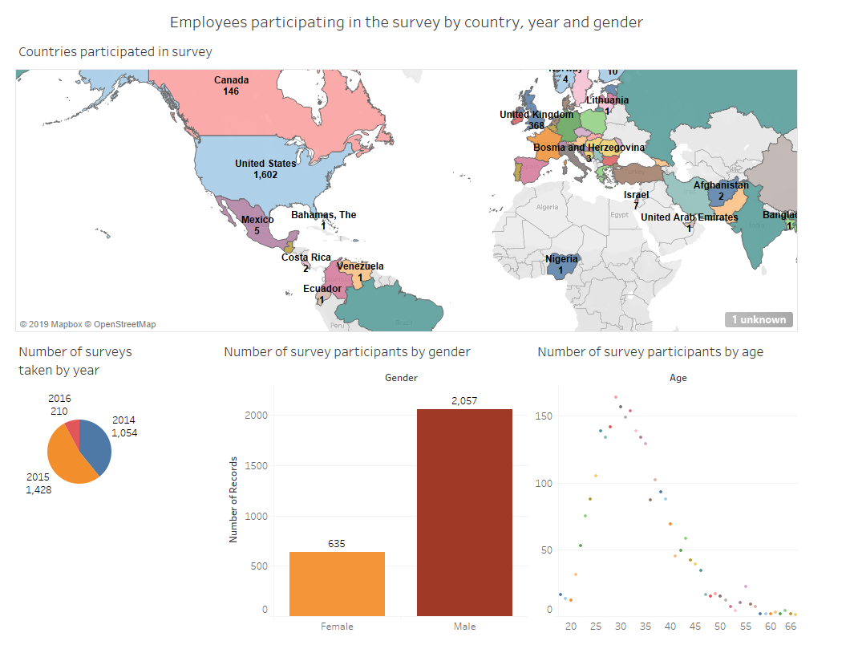

The above dashboard shows the countries where the surveys were taken, the year when the survey was taken, participants count by gender and their age. It can be seen that predominantly the survey was taken by employees working in the United States with more than 50% of the total survey. Also, the number of surveys taken has increased from the year 2014 to 2015. The year 2016 has only a few surveys as it contains survey information for only January and February months. When it comes to gender, males have shown more interest in participating in the survey with approximately 75% of the surveys being taken by them. Furthermore, we can infer that employees between the ages of 25 to 45 have shown more interest in taking this survey.

**DASHBOARD 2:**

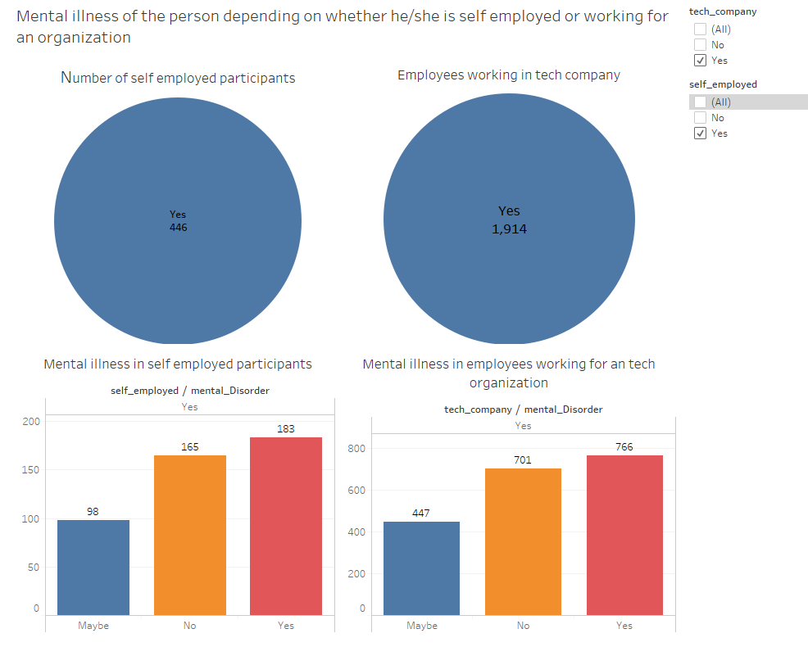

This dashboard provides us the information about how mental illness varies within employees working in an organization and self-employed. We can see that more than 70% of the participants taking part in the survey are working in a tech company. First two charts shows the number of employees who are self employed or working in an organization. The next two charts show the mental illness among self-employed and employee working in an organization. We can see that approximately about 40% of the employees working in the tech company are suffering from mental health issues. On the other hand, same number of employees also says they are not suffering from mental health disorder. Furthermore, we can observe that there is less number of self-employed who are suffering from mental health issues when compared with the non self-employed participants. Employees who are not self-employed could be employees working for an organization or employees who are currently not working. Less work pressure from the supervisor and self-employed professionals have the freedom to decide their working hours which reduces their mental health issue.

One actionable insight that can be taken from this information is promoting self-employment as it seems to reduce mental health issues.

**DASHBOARD 3:**

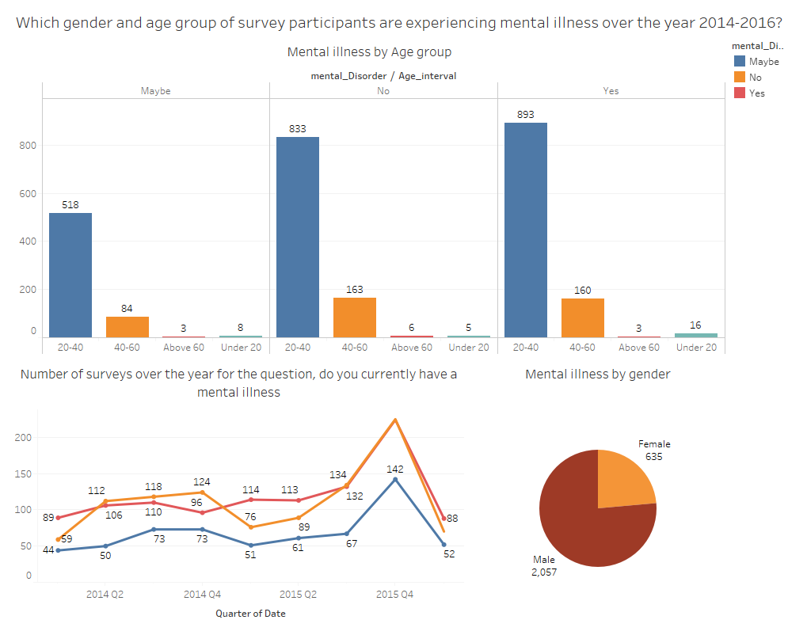

The above information shows the information about mental illness among certain age group, gender of the person and number of surveys taken over the year 2014-2016. First chart provides us the information about mental disorder, second provides us the information about number of surveys taken over the years and third provides the gender of the participants.

From the above dashboard we can see that survey participants with age group 20-40 have been experiencing mental disorder highly when compared to participants with the other age group. Also we can see that the number of survey taken has increased over the years. More than 70% of the participants who have participated in the survey are males.

The dashboard below shows the number of males and females within the ages of 20-40 and 40-60 suffering from mental illness and the number of surveys taken by them.

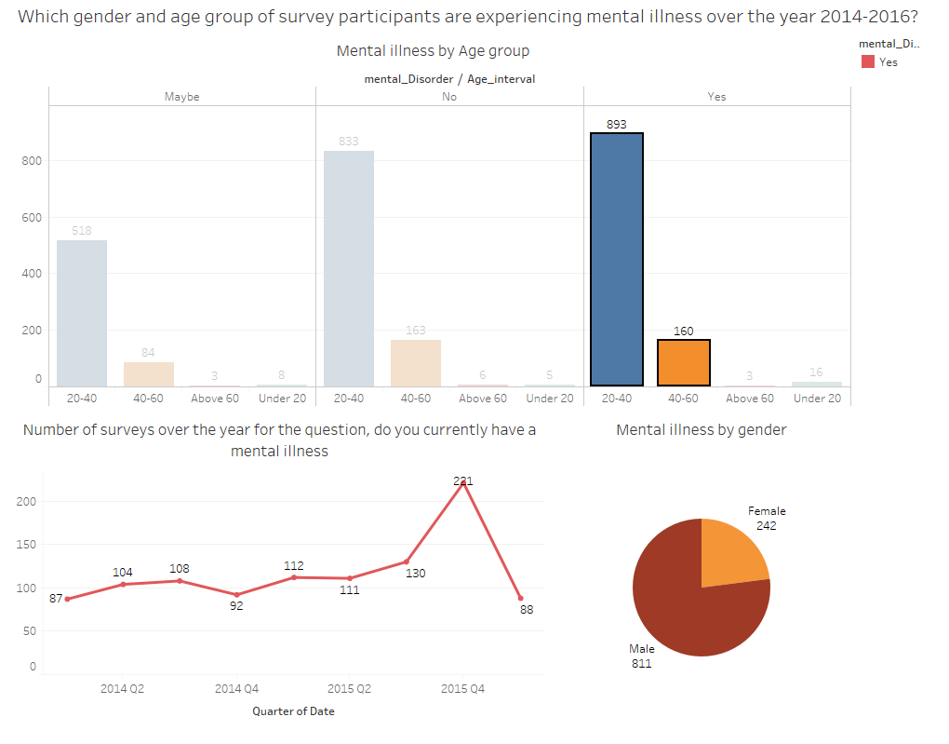

From this we get an insight that number of males suffering from mental disorder is 3 times more than the females in age group 20-40 and 40-60.

Actionable insight that could be provided to organizations could be conduct campaigns that help employees know what the company is providing such as medical care, holidays to recover, etc for mental health issues.

**DASHBOARD 4:**

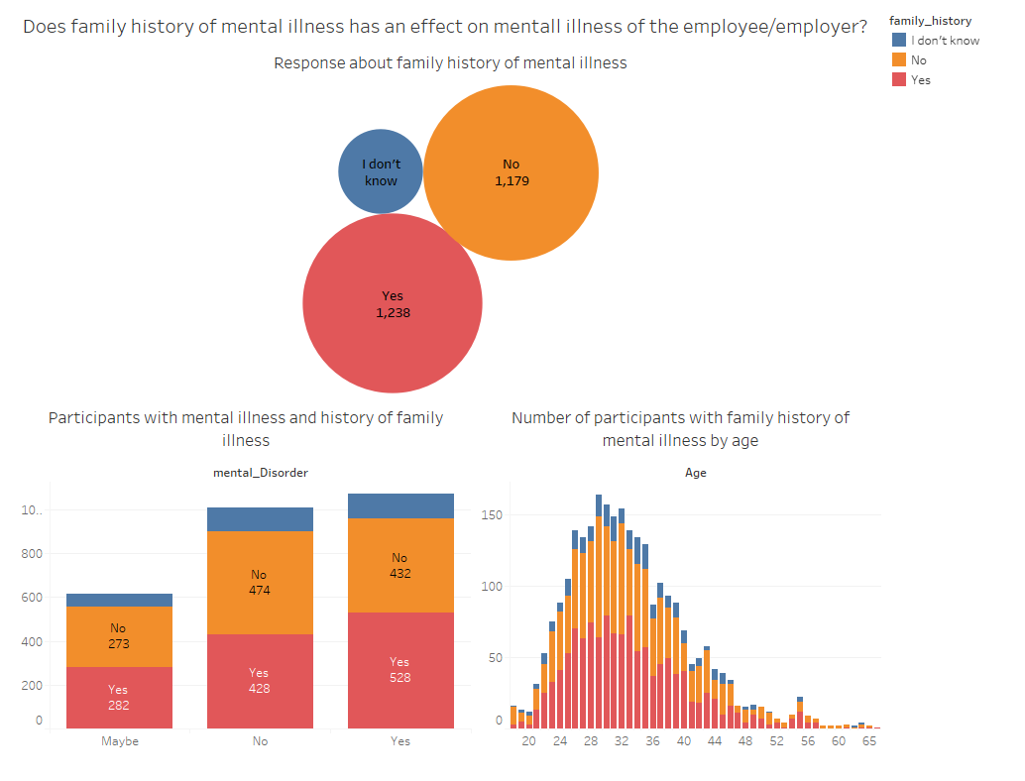

The above dashboard shows if the participants suffering from mental disorder has any family history of mental illness. The first graph shows the overall response from the participants. Second graph shows the number of participant’s mental disorder and having family history of mental illness and third graph shows the age wise response from the participants regarding family history of mental illness.

It is often known that people with family history of mental illness are more vulnerable to develop mental illness when compared to others. We can see that approximately 50% of the participants with mental disorder share a family history of mental illness. Also, we can see that participant between the ages 24 to 36 have high rate of family history of mental illness.

The variation of this dashboard shows how the mental disorder varies for participants with family history of mental illness:

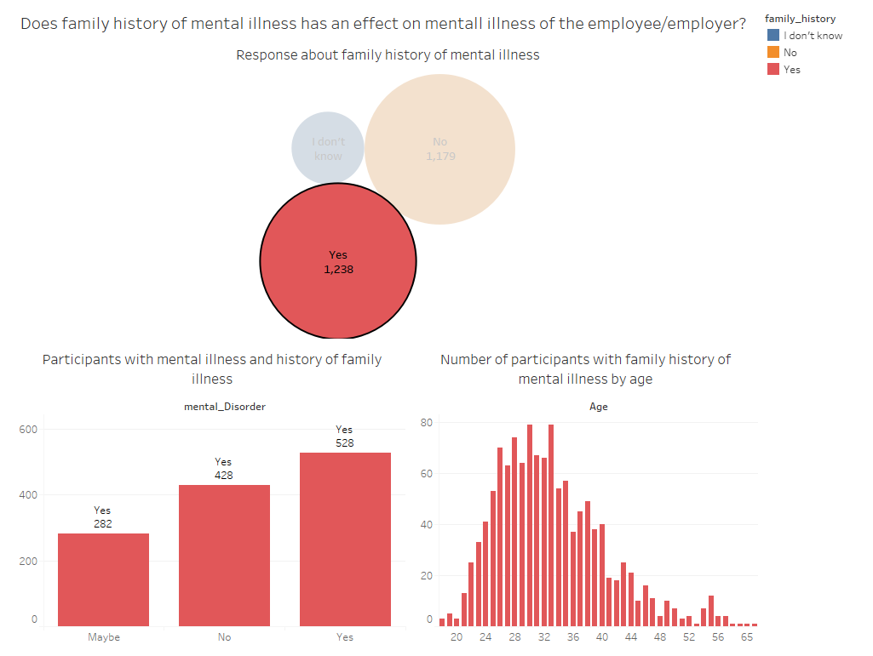

From the above dashboard we can infer that approximately 50% of the participants who have agreed to have family history of mental illness are also suffering from mental disorder currently. Around 40% of the participants who have family history of mental illness are not currently suffering from mental disorder. Also we can see that participants with age 25 to 40 have responded saying they have family history of illness.

Hence an actionable insight could be that employees with family history need to take care so that it does not affect them. Insight to the companies can be to learn if the employee has family history of mental illness and ensure the employees are aware of the benefits provided by the company.

**DASHBOARD 5:**

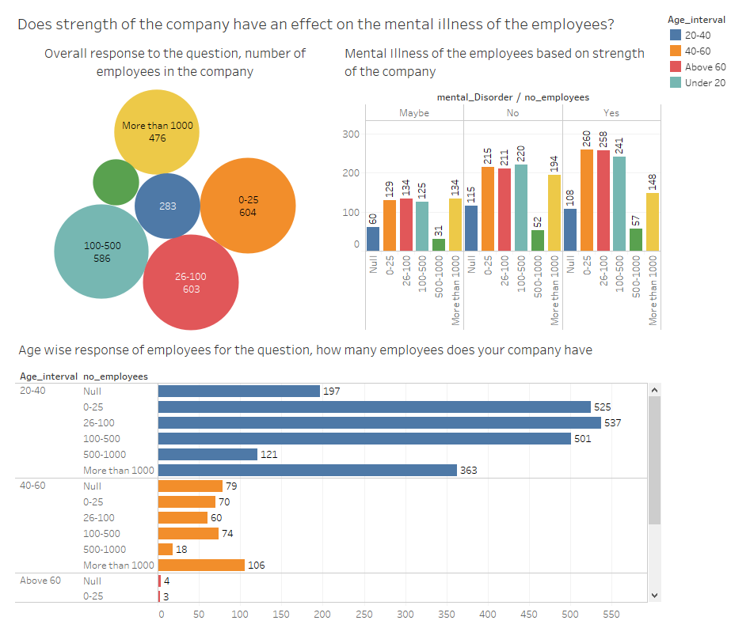

The above dashboard provides us the information about how number of employees in the organization/company plays an important role in the mental illness of the employees. First chart displays the overall response from the participants about the strength of their company. Second provides the mental status of the participants based on strength of the company and third graph displays the age wise response of the participants.

We see that people working in companies with strength between 0-500 are more vulnerable to mental illness when compared to persons working in companies with more than 500 employees. Also, more number of employees is between the ages of 20-40.

The below dashboard further shows how many employees with mental disorder are working in a company with strength 0 to 500.

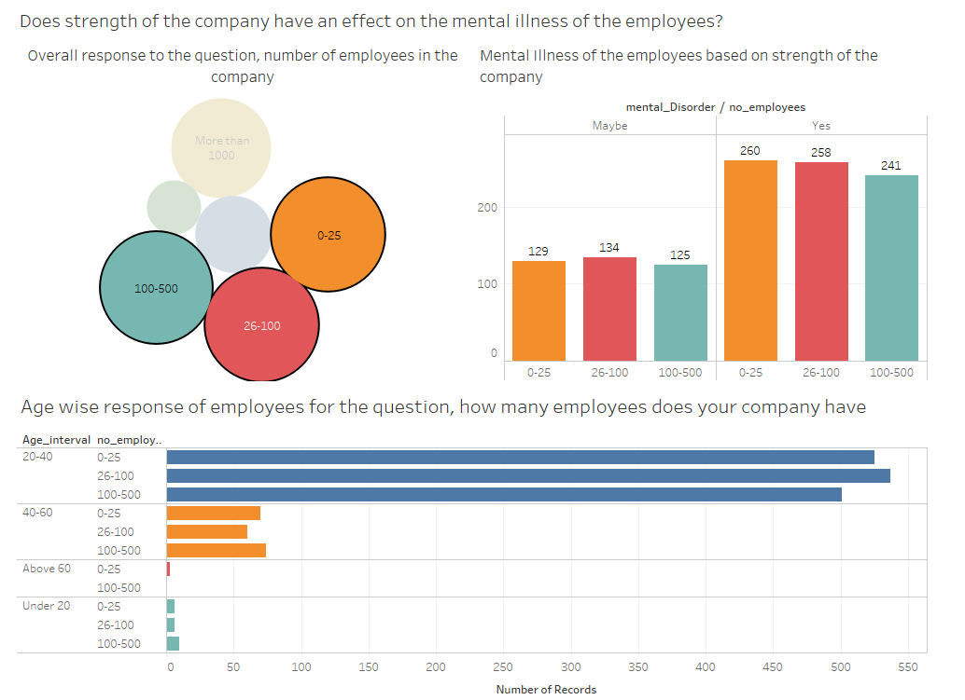

After looking at the above dashboard we can say that more than 30% of the employees with mental disorder are working in a company whose strength is 0 to 500. Another noticeable factor here is that most of the employees with mental disorder are between ages of 20-40.

In small companies, an employee is required to handle multiple tasks simultaneously, which could affect the mental status of the employee. One of the actionable insights, for the company, to reduce mental illness among employees would be to hire more employees, if their budget permits, so that employees would need to handle only specific tasks at one time and not multiple tasks which subsequently maintain their mental health.

**DASHBOARD 6:**

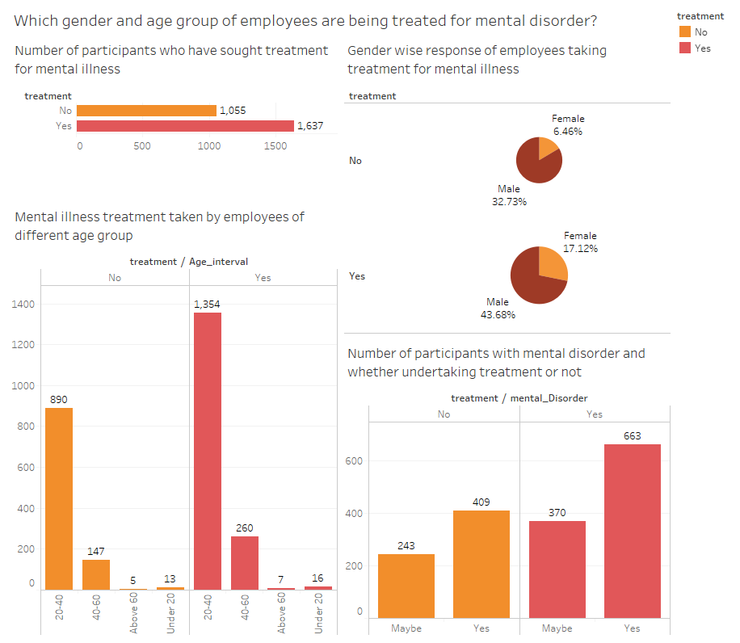

The above dashboard shows the participants who are undertaking treatment for mental disorder according to their age and gender. First graph shows the overall response of the participants. Second chart display the percentage of gender under treatment, third graph shows the age group of the participants who are taking treatment and fourth graph shows whether the participants who are suffering from mental disorder are taking treatment or not.

Approximately 60% of the survey participants are taking treatment for mental illness. Also, it can be seen that high percentage of males is under treatment for mental illness. Furthermore, more number of employees with age group 20-40 is under treatment for mental illness. Another noticeable observation is that approximately 60% of the participant who have answered ‘yes’ or ‘maybe’ to mental disorder are taking treatment.

The below dashboard shows the response of employees who are currently taking treatment for mental illness:

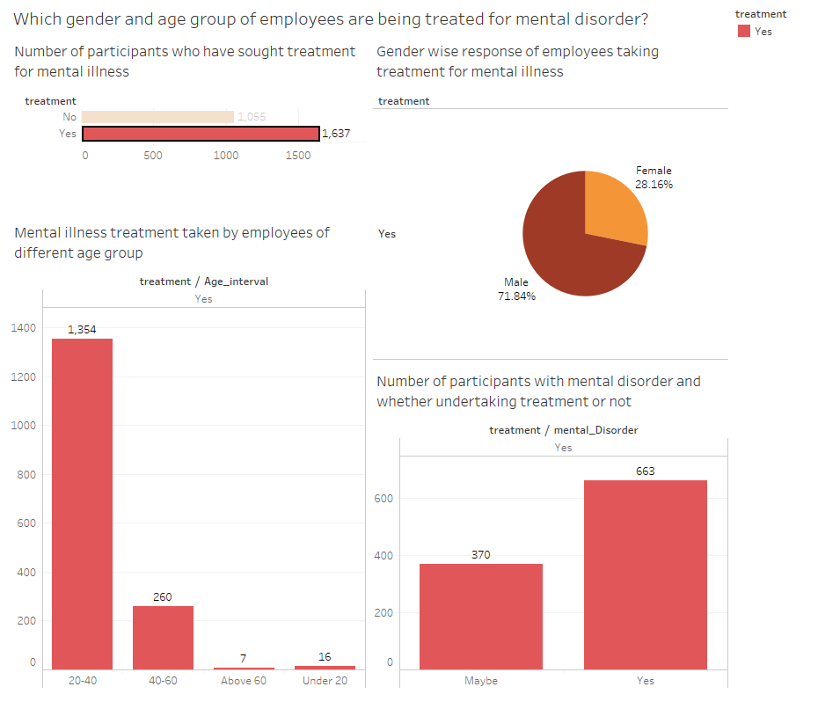

From this we can observe that 72% of the participants who are taking treatment are male and more than 75% of the participants are in the age group of 20-40. Also we see that most of the participants suffering from mental disorder are taking treatment.

Mental illness could be due to work pressure or personal problems. Most of the participants with mental disorder are taking treatment which is a good sign. However, it is necessary that employees who are suffering from mental illness and not undertaking a treatment should be convinced to take treatment. With the company perspective, several campaigns and counselling sessions needs to be conducted for an employee showing the steps to avail the benefits and how their identity is preserved so that it does not affect their relationship with the co-workers.

**DASHBOARD 7:**

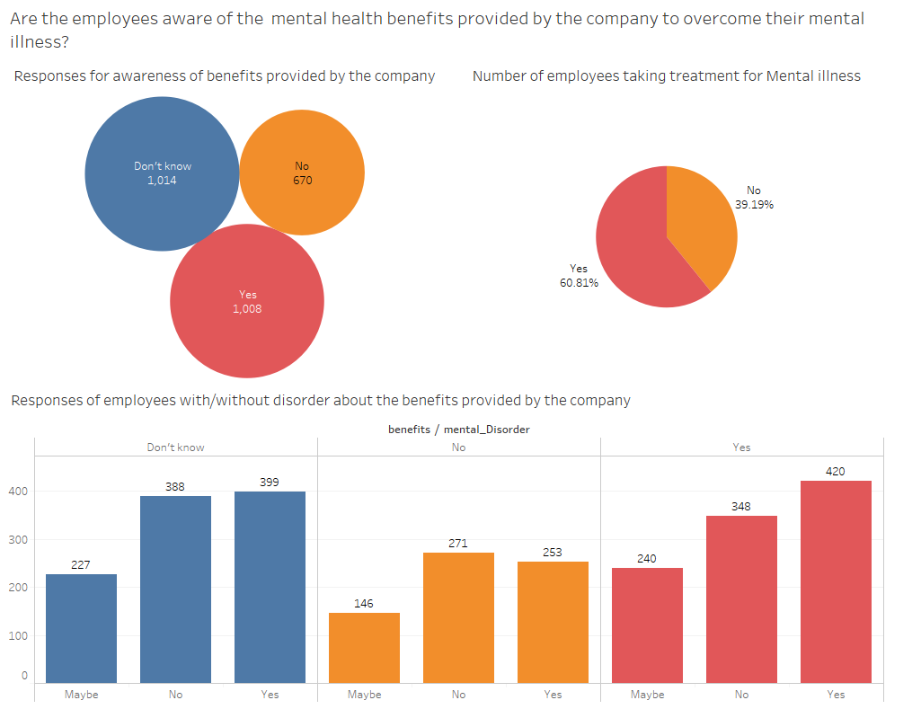

The above dashboard shows whether the employees are aware of the benefits provided by the company for mental health issues. First graph shows the overall response of the survey participants. Second chart shows how many participants are currently taking treatment for mental illness and third graph shows if the participants are aware of the benefits provided by the company irrespective of whether they are suffering from mental disorder.

As we can see approximately 75% of the employees are either aware of the benefits provided by the company or they are not sure. Only 25% of the employees are completely not aware of any benefits provided by the company. Also, we see that 60% of the employees are currently taking treatment for the mental illness.

The below dashboard shows how mental illness among employees who are aware and not aware of the benefits provided by the company:

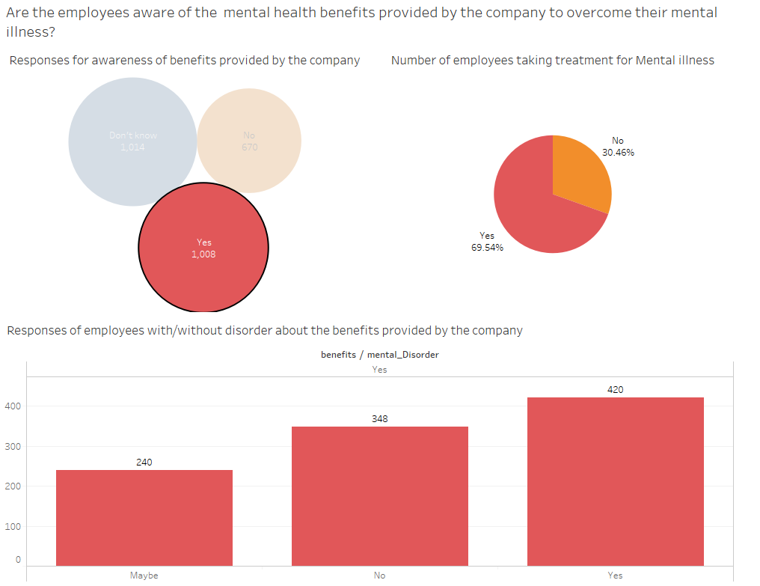

From the above dashboard we can see that 70% of the participants who are aware of the benefits provided by the company are currently undertaking the treatment. Also we see that 420 participants suffering from mental disorder are aware of the mental health benefits.

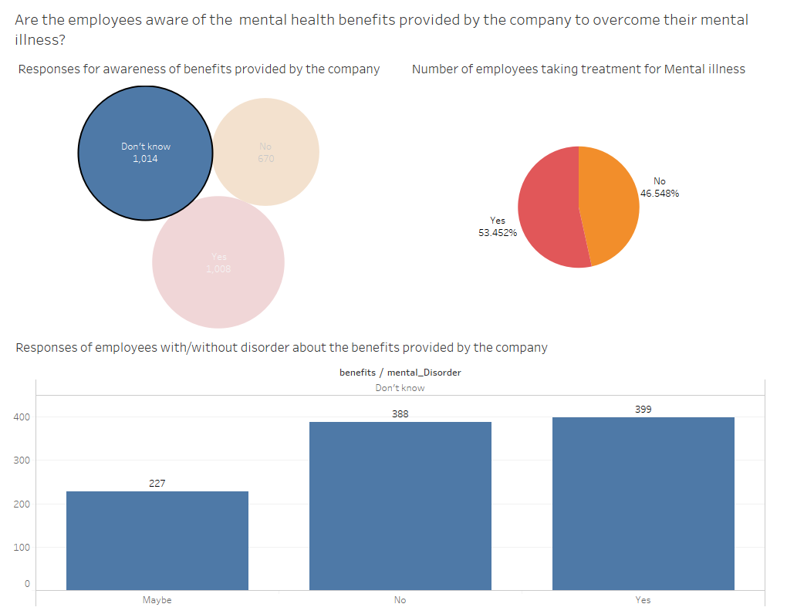

We can see that there 399 survey participants who are suffering from mental disorder and are not aware of the benefits provided by the company. Also, we see that there 54% of the employees who are taking treatment and are not aware of the benefits.

Since there are more participants who are not aware of the benefits and suffering from mental illness, it is necessary that the companies inform about the mental health benefits they are providing so that the employee can avail those benefits to recover themselves from mental health issue. Conducting regular training sessions or having a certification regarding benefits provided by company could help employer spread awareness of the benefits to its employees.

**DASHBOARD 8:**

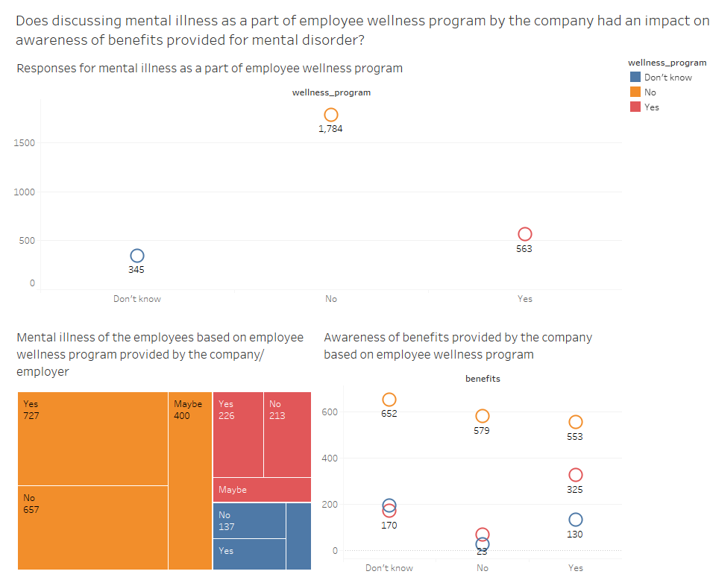

The above dashboard shows how discussing mental health as a part of employee wellness program had an impact on creating awareness of the benefits provided by the company for employee’s mental health issues.

The first graph shows the overall response of the survey participants regarding discussion of mental health as a part of wellness program. Second map shows the employee mental status based on the wellness program and third graph shows the awareness of benefits provided based on employee wellness program.

We can see that employee mental illness is more among employees where mental health was not discussed as a part of wellness program. Also we see that participants are not aware of the benefits provided if the wellness program was not discussed.

The below dashboard shows provides us more information for the case where mental health is not discussed in employee wellness program:

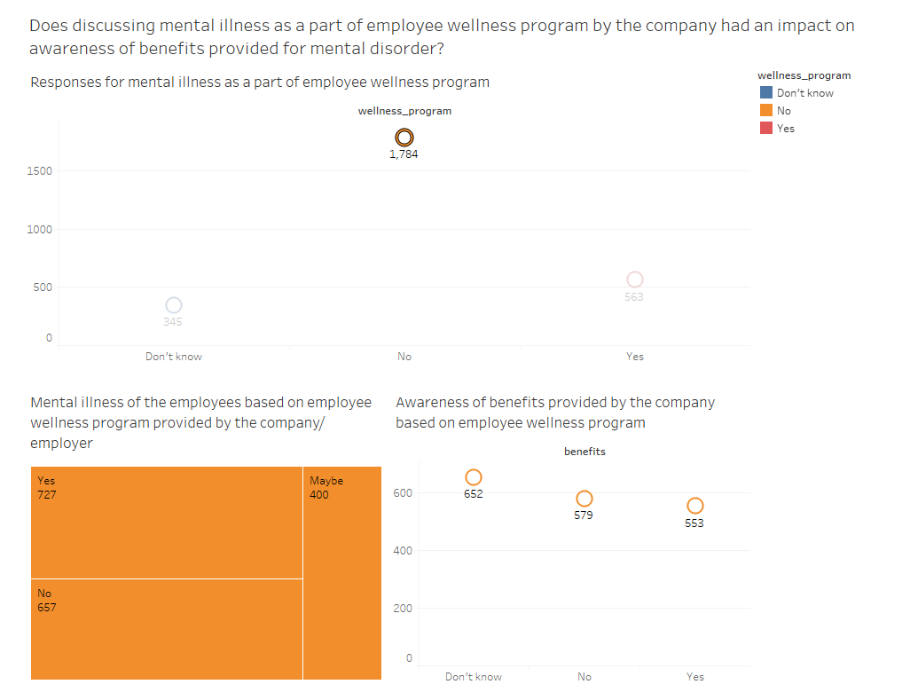

Out of 1784 participants where mental health was not discussed as a part of employee wellness program, 727 participants are suffering from mental health disorder and around 70% of the employees are not aware (don’t know or No) of the benefits provided by the company.

As we see many participants with mental illness and less awareness of the benefits, employer should ensure that mental health is compulsorily discussed as a part of employee wellness program and provide ample resources to make the employees acquaint with the benefits.

**DASHBOARD 9:**

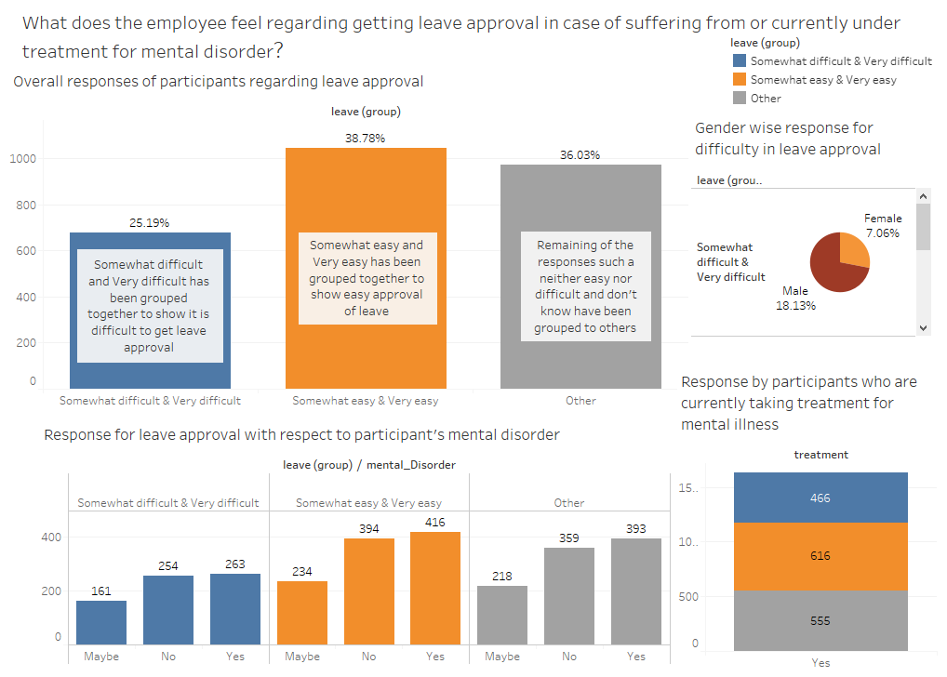

This dashboard shows the survey participants responses to difficulty in getting leave for mental health issues. First graph shows the overall responses from all the participants. Second chart display the responses based on gender. Third graph displays the responses based on whether the participant is suffering from mental disorder or not and fourth graph shows the responses from participants currently undertaking the treatment for mental health issue.

We can observe that approximately around 40% of the participants have agreed that it is easy to get their leave approved, around 25% say it is difficult and rest are not sure if it is or not. We also see that many participant suffering from mental disorder have said either it is easy or neither easy nor difficult to get the approval.

The below dashboards shows the details for response by participants who said it is easy to get the leave approval:

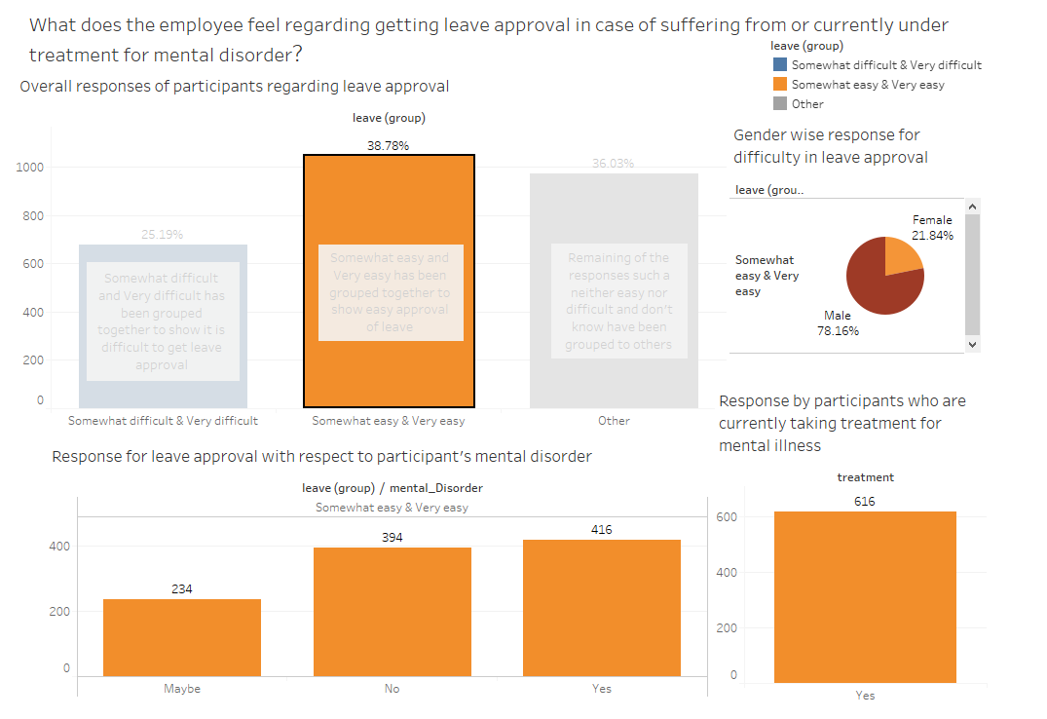

From this dashboard we can infer that 416 participants who are suffering from mental disorder have agreed for easy approval of leave and 78% of them are male and rest is female. Noticeable information here is that 616 of the participants who are currently undertaking treatment have also agreed easy approval of leave in case of mental illness.

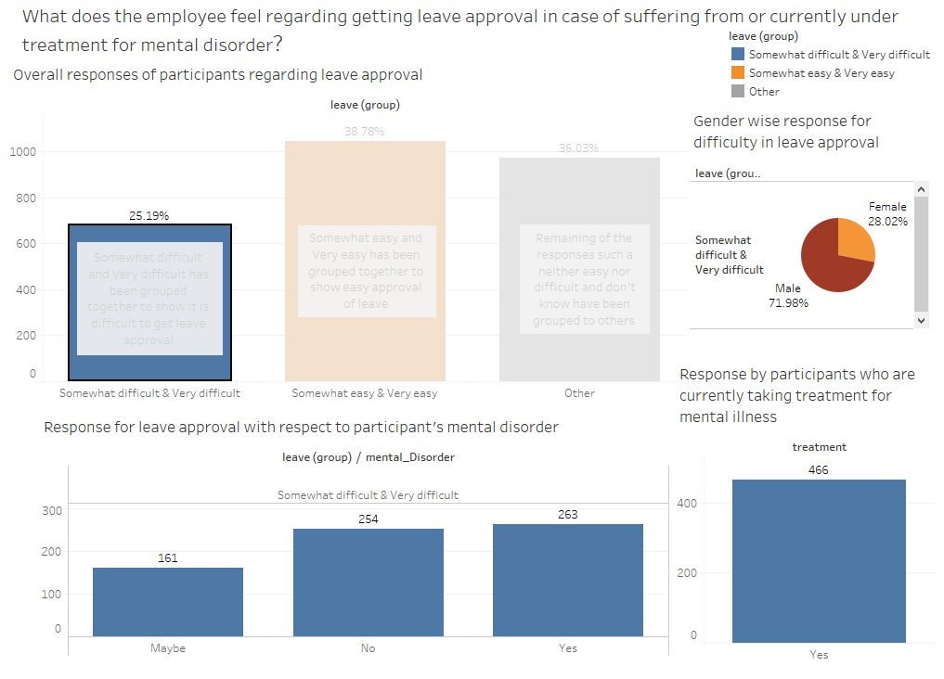

From this filter we can see that there are employees who are suffering from mental illness and have difficulty in getting leave. 466 participants who are currently under treatment for mental illness say it is difficult to get leave in case of mental disorder.

In order to overcome this, companies can have a separate set of leaves which can be availed by their employees if they are in mental stress or suffering from a mental disorder.

**DASHBOARD 10:**

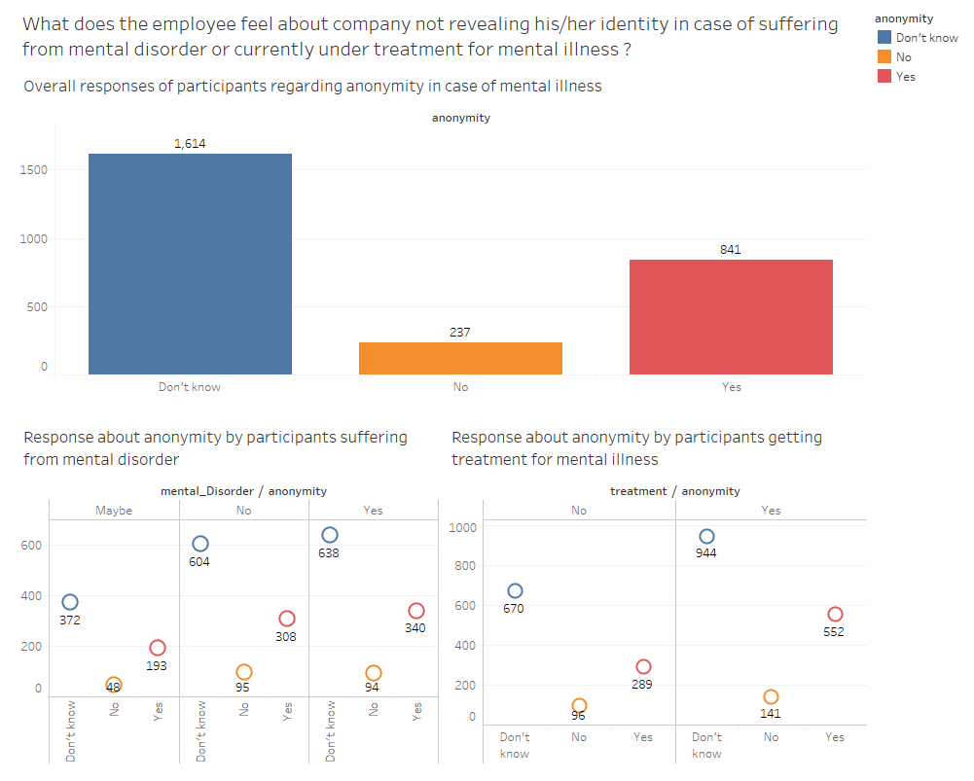

The above dashboard shows the survey participant responses about whether the company is respecting their anonymity if they open up about their mental illness or about their treatment. First graph shows the overall responses from the participants. Second graph shows the responses based on whether the participant is suffering from mental disorder and third shows the response from participants who may or may not be taking treatment.

We can see more than 60% of the participants are not sure if their identity will be preserved by the employer if they confess about their mental health problem. Only few participants feel that their anonymity will not be preserved by the company. In addition, 841 participants feel that their anonymity will be respected by the company.

In the below dashboard, we see the response from participants who are not sure about company respecting their anonymity:

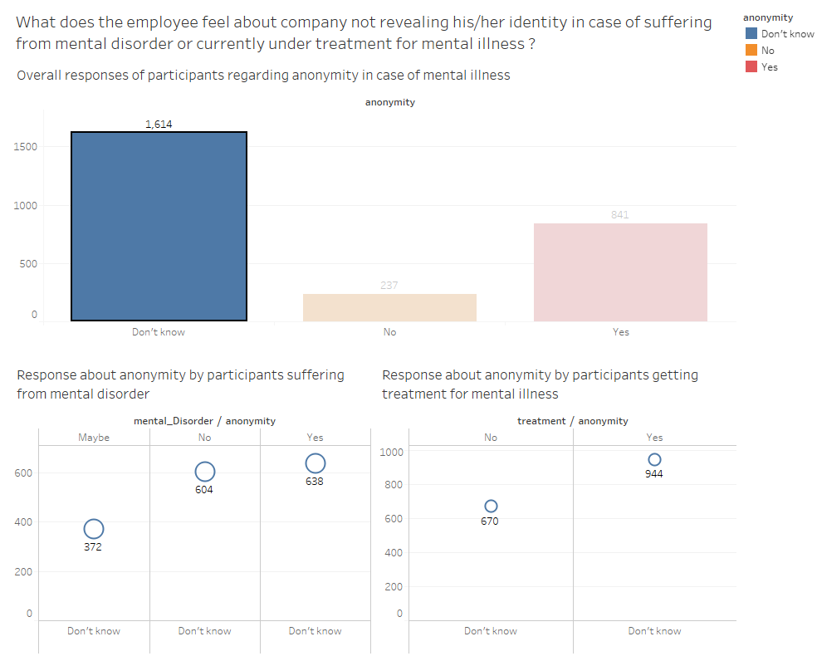

From this we can observe that most of the participants, irrespective of whether they are suffering from mental health problem or not, whether they are currently undertaking treatment or not, are not sure about their company respecting their identity in case of mental health issues.

One actionable insight that can be taken after looking at these dashboards is that the employer should conduct seminars and training on how the employee’s identity would not be revealed if they are suffering from mental health problem. Also, companies can create and share resources that can be viewed by all the employees regarding the preservation of their identity.

**DASHBOARD 11:**

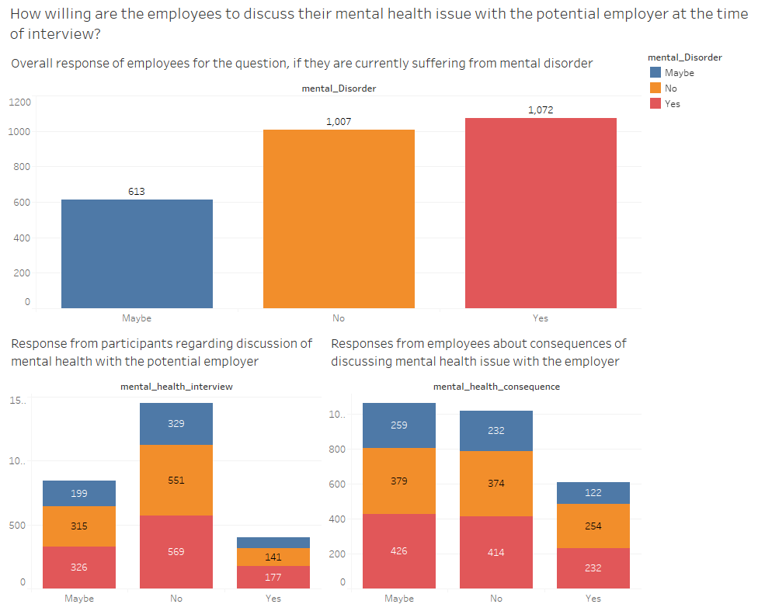

The above dashboard shows the response of participants about their mental disorder, discussing about mental health with their potential employer and about its consequences. The first graph shows the overall response about the employee mental health problem. Second graph shows the response based on mental disorder and third shows the views about consequences of discussing mental health issue with the potential employer.

As we can see, 40% of the overall participants are suffering from mental health disorder.

The below dashboard shows the response from participants with mental disorder regarding mental health interview and its consequences:

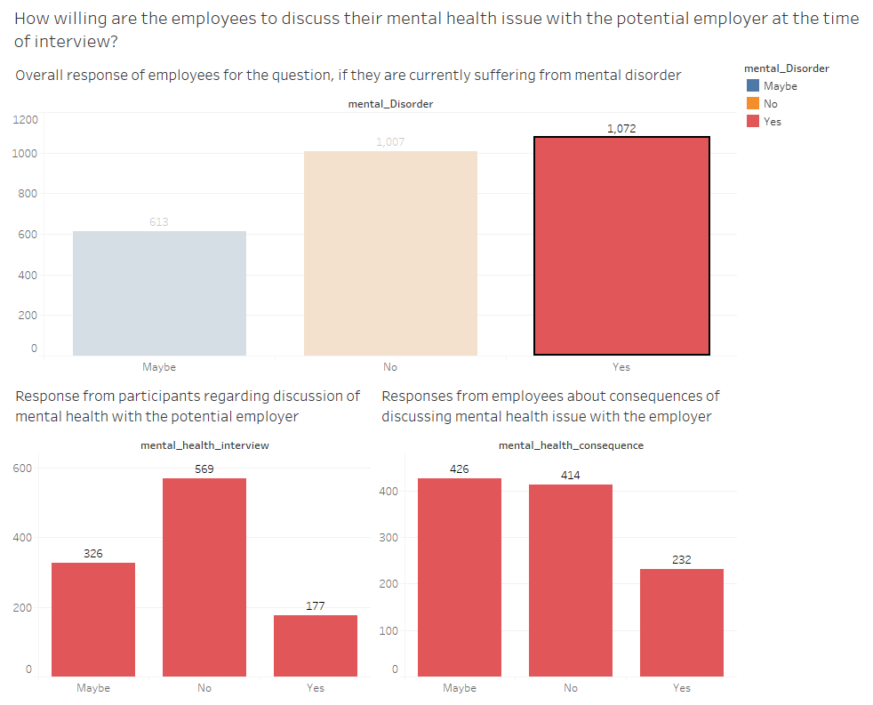

From the above dashboard we can see that more than 50% employees suffering from mental disorder are more unlikely (response ‘No’) to discuss their mental health with the potential employer. Also, approximately 40% of the employees feel there might be consequences of discussing health issue with the employer.

The below dashboard shows the response from participants who are not suffering from mental disorder:

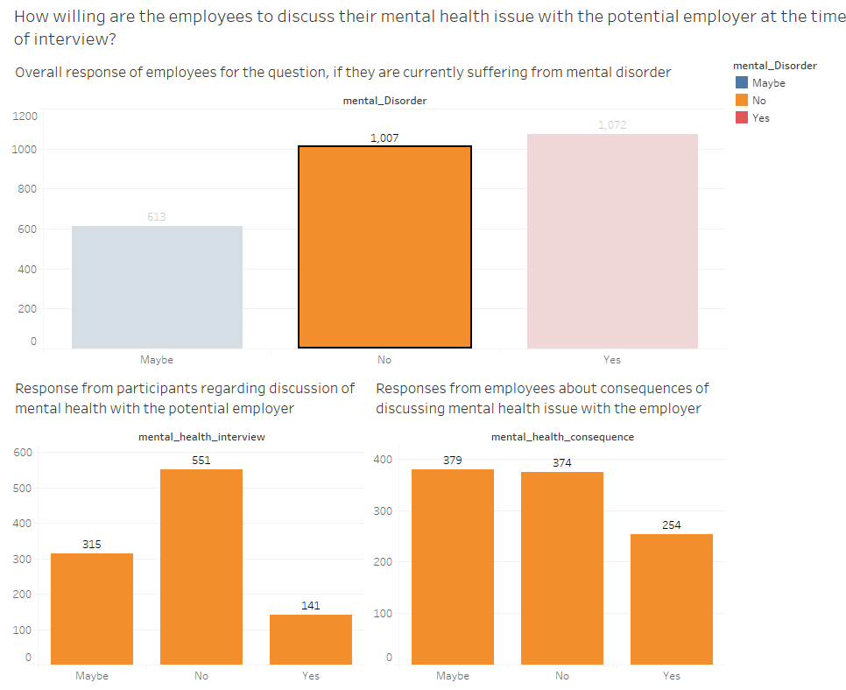

We can see that 50% of the people who are not suffering from mental health problem also do not prefer discussing mental health problem as they feel there might be consequences.

As we have seen in our previous dashboards, very few employees are aware of the benefits, care options and resources provided by the companies. Due to this, employees feel there might be negative consequences on their work and fear to discuss it with the potential employer. Hence, an actionable insight could be conduct sessions explaining measures taken by the companies such as benefits, leaves, preserving identity, etc., to overcome mental illness among employees.

**DASHBOARD 12:**

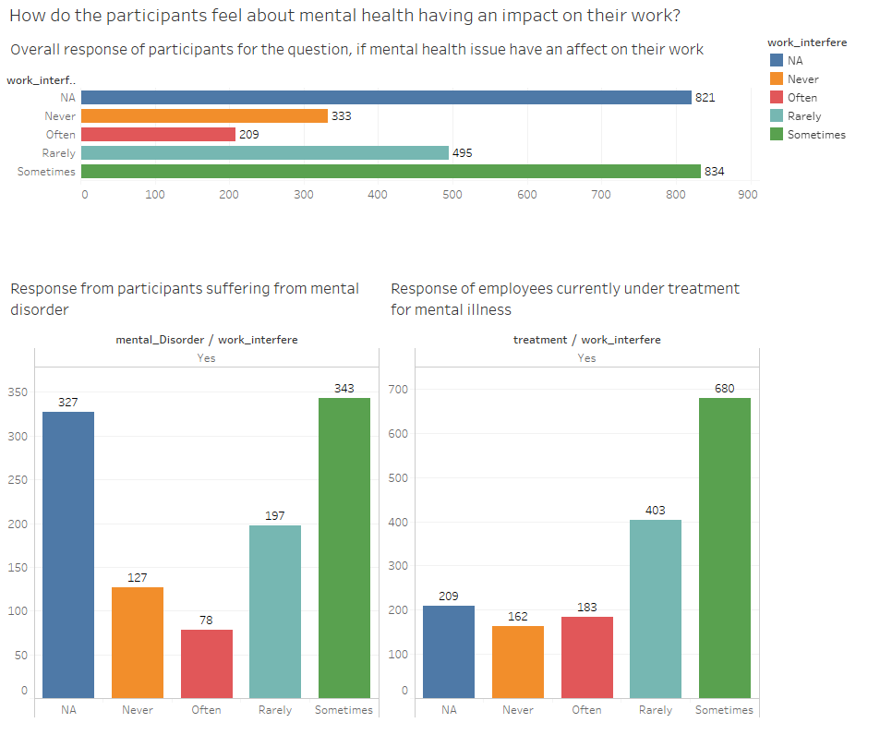

The above dashboard shows how the survey participants feel about mental health problem having an impact on their work. The first graph shows the overall response, second graph shows the response from employees currently suffering from mental disorder and third graph contains the response from employees currently undergoing treatment for mental health problem.

We can observe that many participants (821) have agreed that it not applicable to them (response NA). Apart from this response we can see participants (834) who feel that mental health issues might have an impact sometimes. Also, we see that 50% of the participants who are suffering from mental disorder have agreed that it will have an impact on their work. Only few participants have said that it will never impact their work. Furthermore, we see that more than 50% of the participant currently undertaking treatment has also agreed about mental illness having impact on their work.

From this dashboard, we get an overall insight that many participants suffering from mental disorder and undertaking treatment feel it will hinder their work.

As an actionable insight, an individual can undertake regular treatment to recover from mental health problem. Companies can conduct regular counselling sessions, reduce work pressure on individual employee and provide mental health benefits to each employee if their budget permits.

**DASHBOARD 13:**

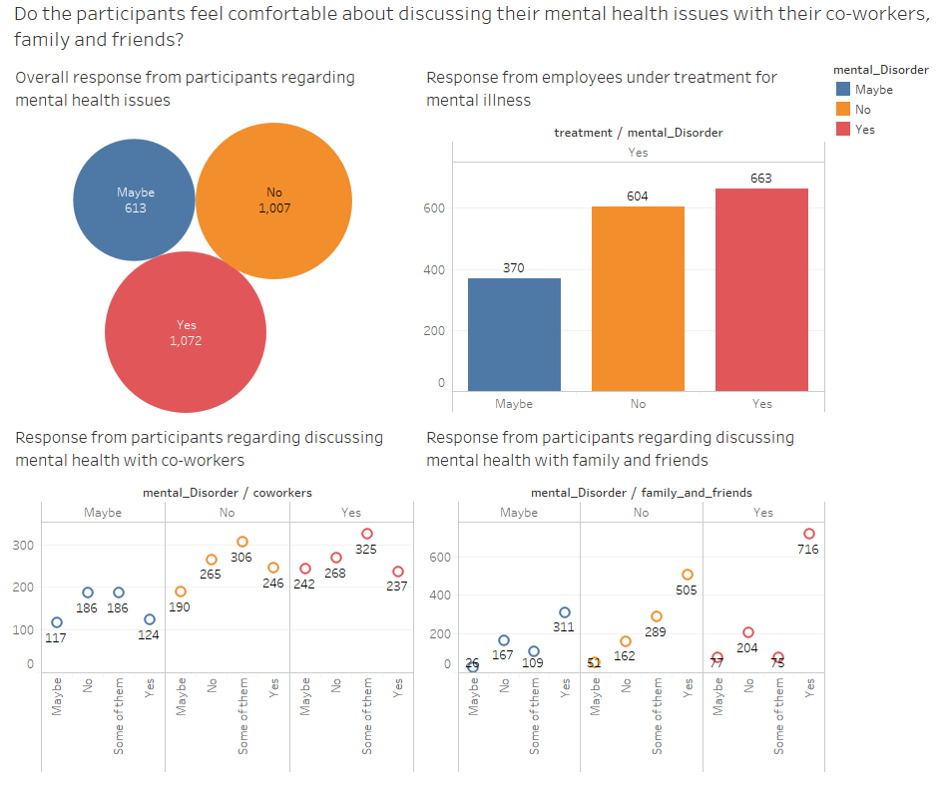

The above dashboard gives information about how participants with mental disorder feel about discussing their mental health problem with their co-workers, family and friends. The first chart provides information about mental health issue, second gives information about participants undertaking treatment for mental health problem, third gives information about discussing health condition with co-workers and fourth gives information about discussing mental health with family and friends.

We can see that approximately 40% of the participants are suffering from mental disorder. Also, we can see that employees suffering from mental disorder feel more comfortable about discussing their mental health issue with their family and friends when compared to discussing it with their co-workers.

The below dashboard provides more information about what participants suffering from mental disorder feel:

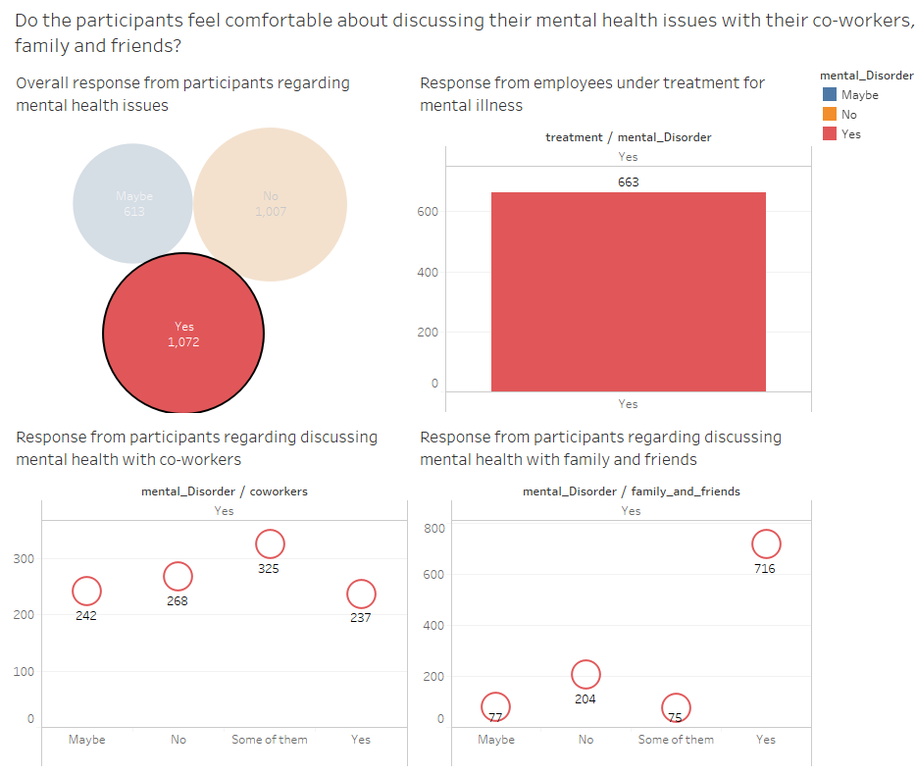

From this we can see that there is equal response when it comes to discussing with the co-workers. However, 70% of the participants suffering from mental disorder are ready to discuss their mental health problem with their family and friends. Also, 663 of employees suffering from mental disorder are currently taking treatment.

We see the participants are not comfortable discussing their mental health problem with their co-workers/ supervisor. Companies can take up certain measures to create awareness among the employees that discussing their mental health problem would not affect the way they are treated in the work environment.

**DASHBOARD 14:**

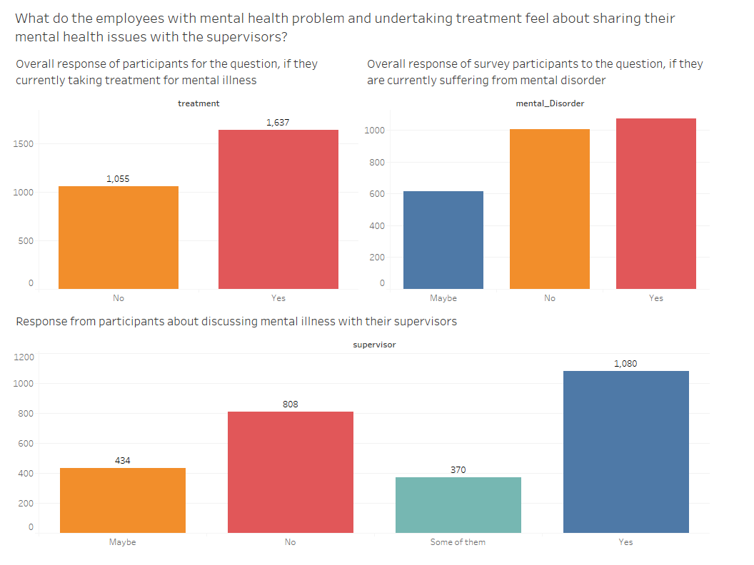

The above dashboard provides the information about how employees with mental disorder and undergoing treatment for mental illness feel about discussing their mental health issue with their supervisors. The first graph shows information about employees treatment, second provides information about employees mental health condition and third provides their responses regarding discussing it with their supervisors.

We can see that approximately 40% (1080) of the participants feel comfortable about discussing their mental health issue with their supervisors.

The below two dashboards shows how participants with mental disorder and undergoing treatment feel:

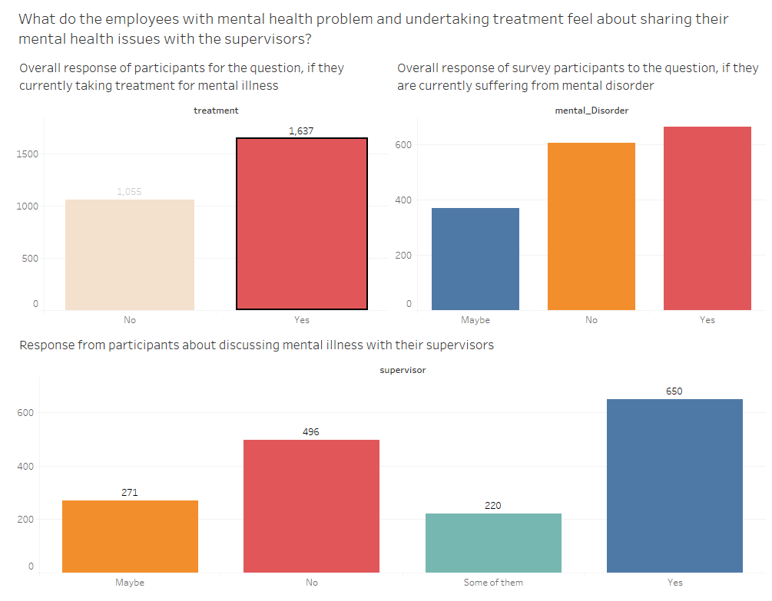

From the above dashboard we can see that out of 1637 participants undergoing treatment only 650 are comfortable discussing it with their supervisors. Out of 1637, 496 participants say they do not want to discuss their mental health problem with their supervisor.

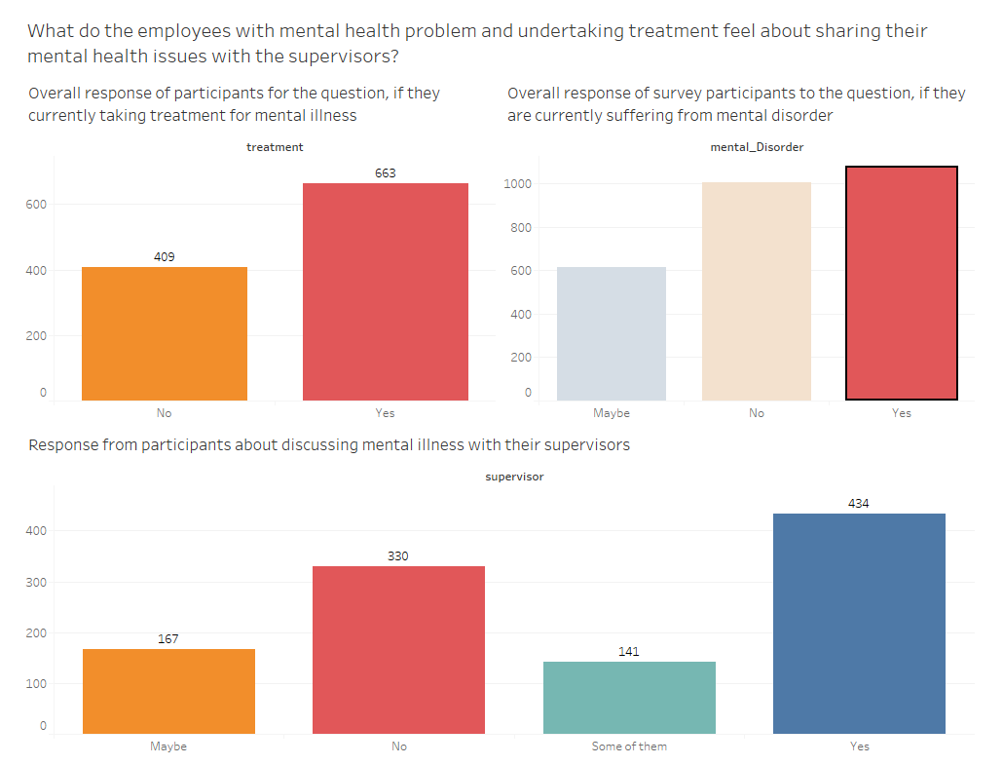

Similar to the participants currently taking treatment, participants with mental disorder also do not feel comfortable discussing with their supervisors. Only 434 of the participants are ready to discuss it with their supervisors.

**DASHBOARD 15:**

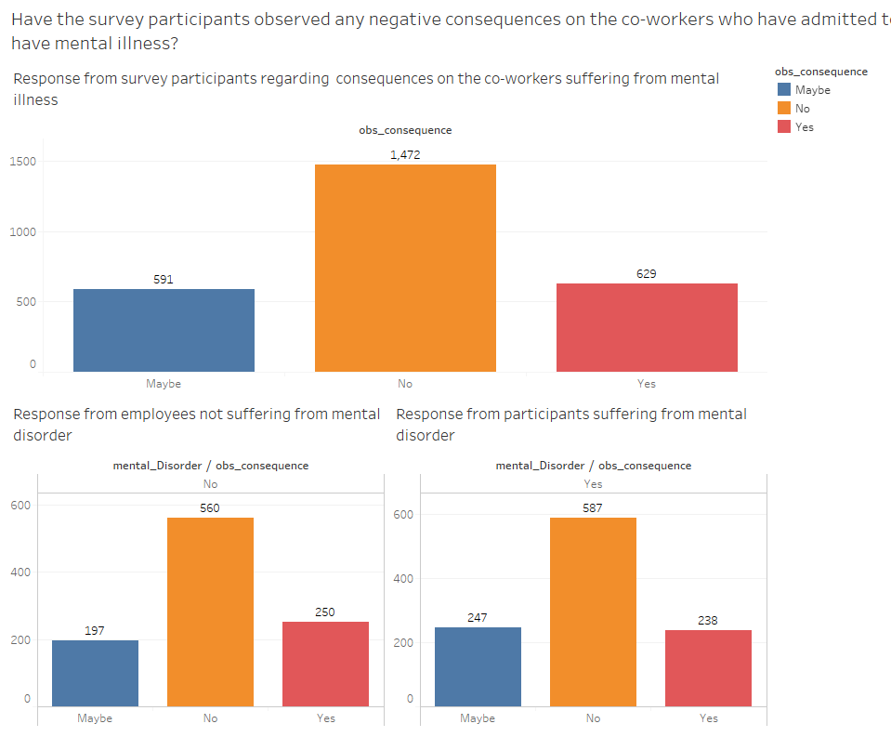

This dashboard shows if the participants with/without mental health problem have observed any negative consequences on the co-workers who had previously admitted to have mental illness. The first graph provides the overall response of survey participants; second graph provides response from employees not suffering from mental health issue and third provides the response of employees suffering from mental health problem.

We can see that more than 50% of the participants have not observed any negative consequences on their co-workers. Also, we see similar responses from participants who are suffering and not suffering from mental disorder. In both the cases, around 50% of the participants have said they have not observed any negative consequences on their co-workers with mental health issue.

**Part -2**

**Predictive Analytics and visualisation of insights**

For the predictive analytics part, we try to use approaches such as association rule mining, decision tree and clustering to find the patterns in the survey regarding mental health issues in the tech company.

Questions to be answered

1. Is the mental disorder associated with other attributes such as number of employees, benefits provided by the company, etc?
2. Can the mental disorder be classified using other information such as treatment, discussing with supervisor, co-worker, friends and family, etc?
3. Is there a relationship between set of responses that are similar and can be grouped separately from other responses belonging to another group?

**Analysis 1: Association rule mining**

As seen in our informative dashboards, mental disorder in the employees can be affected by certain factors such as family history, strength of the company, benefits provided by the company, age of the employee, etc. Hence we use association rule mining to determine the hidden pattern in the responses of this survey.

We try to employ association rule mining to discover if there is any association between the participant suffering from mental disorder and other factors such as family history, number of employees in the company, wellness program provided by the company, awareness of benefits, etc.

Association rule mining is used to find frequent patterns, associations, correlations, or causal structures among sets of items or objects in transaction databases, relational databases, and other information repositories.

These rules are of the form **Y 🡪 Z[support, confidence], where support, s, is the probability that a transaction contains {Y🡪Z} and confidence, c, is the conditional probability that a transaction having Y also has Z.**

Association rule does not necessary imply correlation or causality. Meaning, not all the rules make sense in the association rule mining. Hence having a complete knowledge of the data will help find important relationships/rules.

We use **Weka** to perform association rule mining using Apriori algorithm that works by generating candidate item set and frequent item set. We first import our dataset into Weka and perform necessary pre-processing and save it as an .arff file.

Parameter setting

Minimum support = 20% (593 instances)

Number of rules to be displayed = 50

Minimum Confidence = 75%

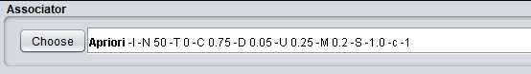

The below figure shows the top 50 best results obtained after performing the Apriori with the above parameter setting.

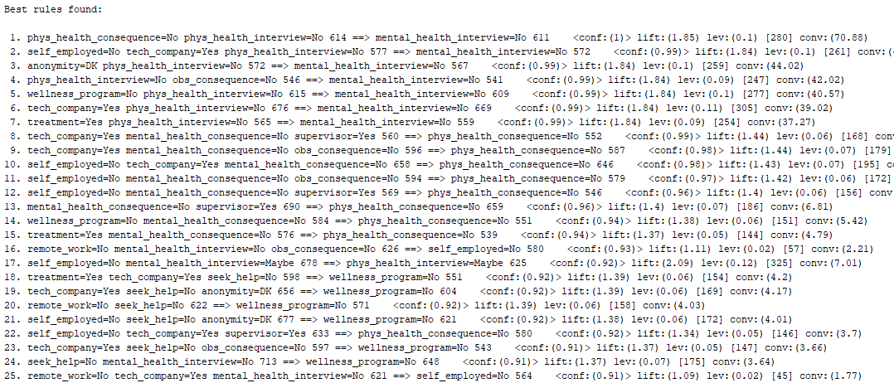

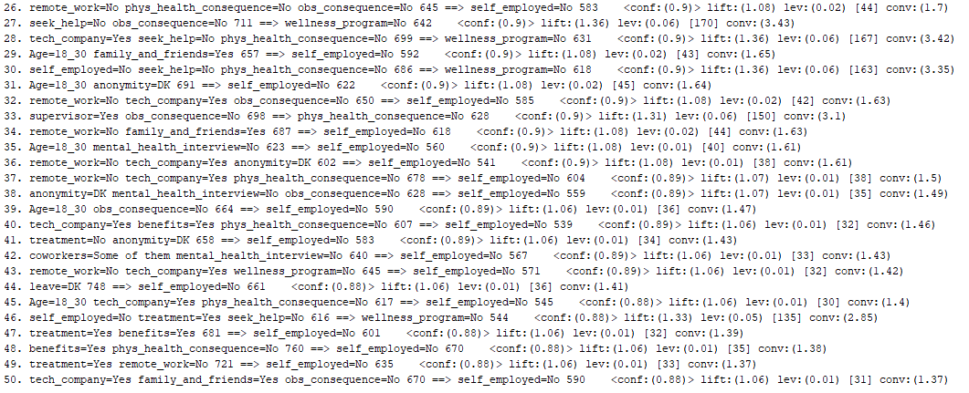

**Some of the interesting rules obtained**



In the above rule, we can see that the participants who are undertaking treatment for mental illness and who say there is no consequence of discussing mental health issue and are ready to discuss mental health problem with the supervisor also feel there is no consequence in consequence in discussing the physical health issues.



In this rule, we see that people who are not given enough resources (seek_help) and are not ready to discuss mental issue with the potential employer also are not discussed about mental health benefits as a part of employee wellness program. An actionable insight could be to discuss mental health issue as a part of wellness program and provide ample resources to the employees to understand the benefits provided by the company.



From this rule, we see that participants who feel comfortable discussing their mental health issue with the supervisor and have not observed any negative consequences on the co-workers before also feel there is no negative consequence of discussing physical health issues.



In this rule, we see that out of 824 participants between the age of 30-42 who are not aware of the wellness program, 623 are also working in a tech company.

**Analysis 2: Decision tree**

The decision tree is an important algorithm for predictive modelling and can be used to visually and explicitly represent decisions. It is a graphical representation that uses branching methodology to demonstrate all possible outcomes based on certain conditions. In decision tree internal node represents a test on the attribute, branch depicts the outcome and leaf represents decision made after computing attribute.

We use this algorithm to predict if the employee is suffering from mental disorder using other information such as family history, number of employees, age, etc.

We use J48 algorithm in Weka to perform this prediction with the parameter settings as below:

Confidence factor for pruning – 0.25

Minimum objects at node - 2



The below figure shows the result of decision tree in predicting mental disorder status of the employees:

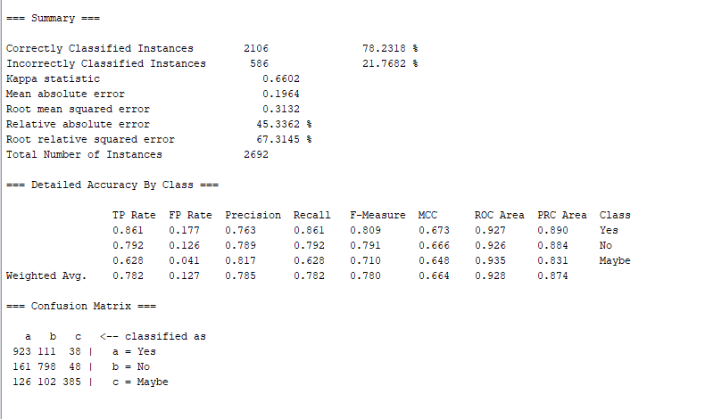

From this figure, we can see that our decision tree algorithm has obtained an overall accuracy of 78% in predicting if the patient is suffering from mental disorder or not. True Positive Rate is reasonably good for predicting all the three responses about mental disorder. Also, we can see that the precision is above 0.7 which says that this model is good in predicting the mental disorder. We also see that all the accuracy measuring factors such as f-measure, ROC area are quite good and we can accept this model.

The below two figures shows the ROC curve for class labels “yes” and “no”.

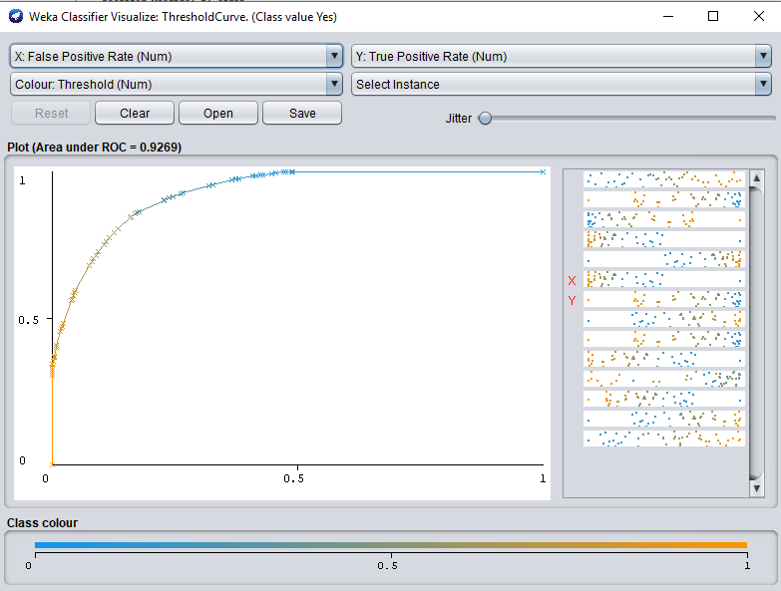

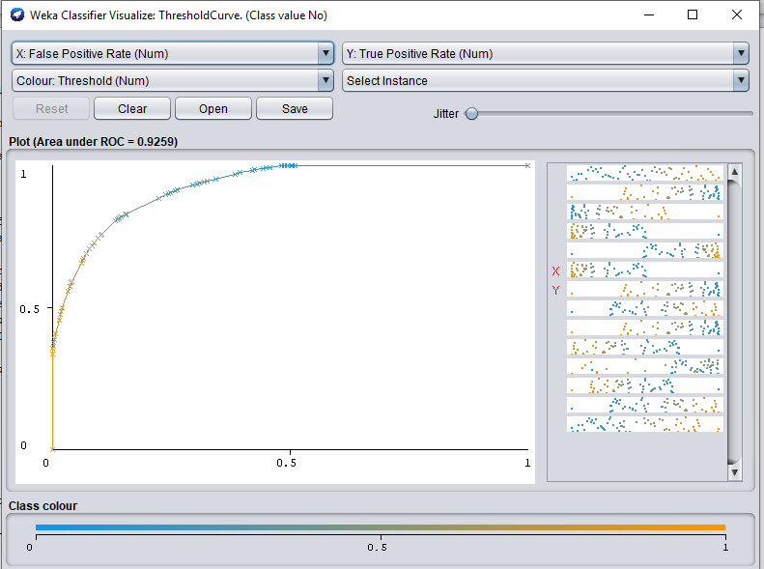

From the above ROC curves, we can say that the performance of the decision tree model is good and can be used to classify mental disorder based on other factors such as family history of mental illness, number of employees in the company, etc.

Below gives the visualisation of the tree obtained from the model to classify mental disorder based on the other factors.

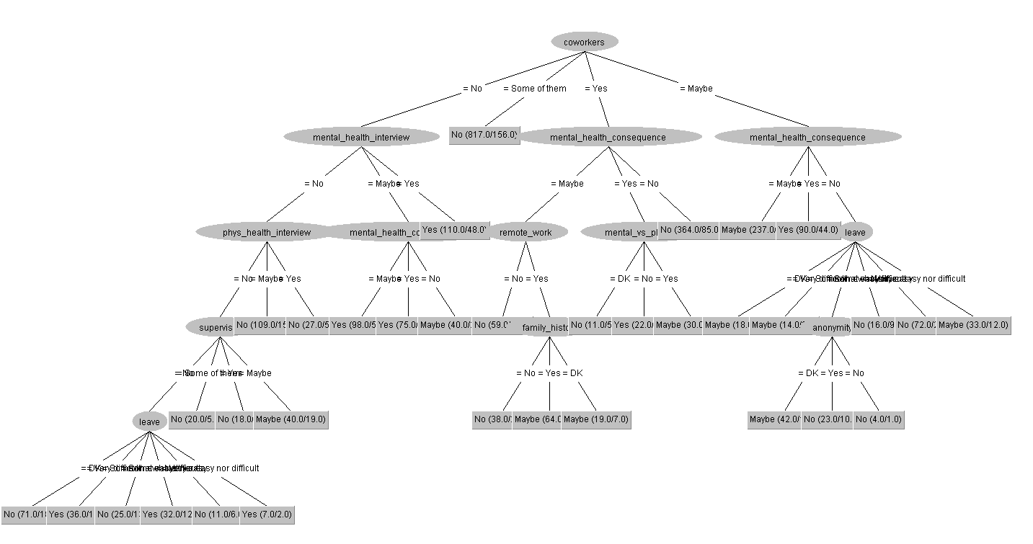

**Analysis 3: Clustering**

Clustering is an unsupervised classification method. Collection of data objects similar to one another within the same cluster and dissimilar to the object in other clusters**.**

Tableau uses k-means algorithm for clustering.

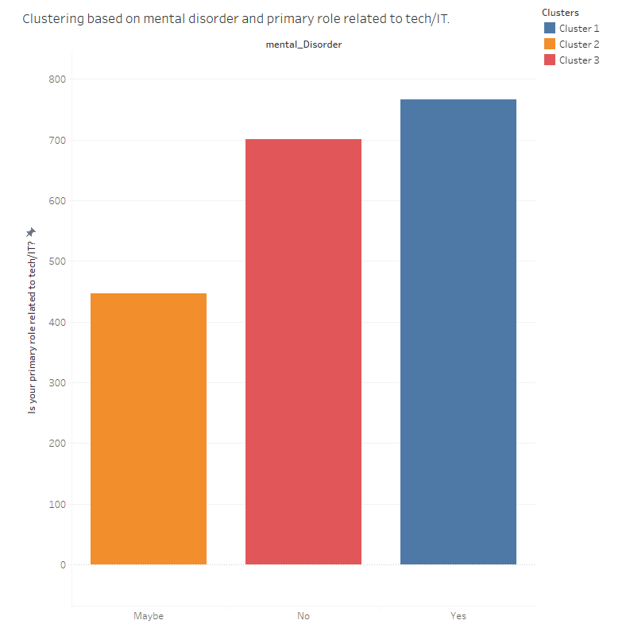

For this clustering process, two variables, the primary role of employee as tech/IT and mental disorder status of the employee are used for clustering. As we can see three clusters have been formed with more number of records in cluster 1 with mental disorder, next highest in cluster 3 without mental disorder and the lease in cluster 2. This clustering helps us understand that more number of participants who are primarily working in IT/tech is suffering from mental disorder.

Actionable insight could be to keep in mind this set of employees and provide counselling, conduct campaign and provide resources to acquaint them with the benefits provided by the company for mental illness.

**Analysis 4: Clustering**

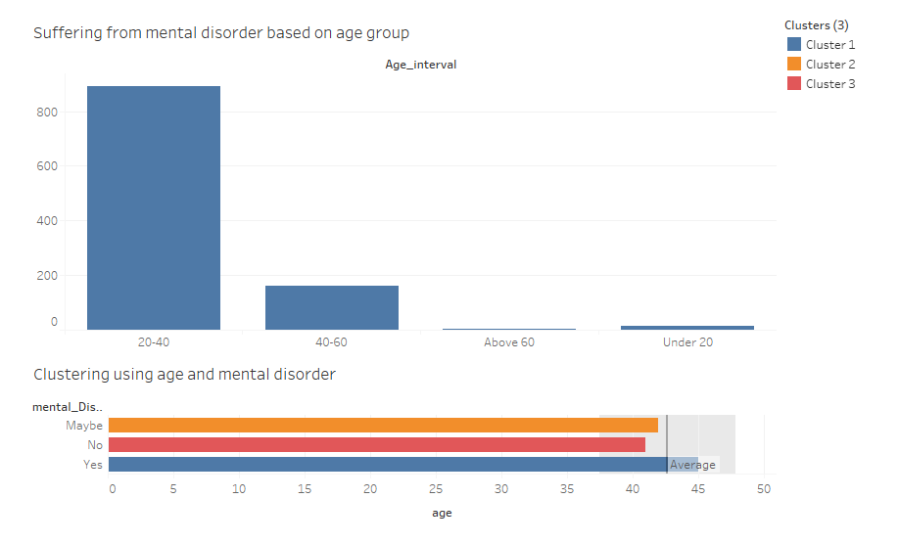

In this dashboard, we perform clustering based on age and mental disorder. We use age and mental disorder status variable for clustering purpose. Clustering process has resulted in three clusters, cluster 3 having the large number of records with employees suffering from mental disorder. Clusters 1 and 2 have same number with/without mental disorder. We can see that employees of age group 20-60 are more vulnerable to mental illness.

Hence, the companies can introduce some new policies to spread awareness and meanwhile ensure every employee is aware of the programs related to mental illness provided by the company.

**Analysis 5: Time series forecasting**

Tableau uses exponential smoothing algorithm to forecasting. Exponential smoothing algorithm tries to find the patterns in the historical data in order to predict the future data.

In our survey dataset, we see that the number of people taking the survey has been increasing over the years. Though we have data only for the years 2014 to 2016, we try to see how the participant response to working remotely has changed over the years.

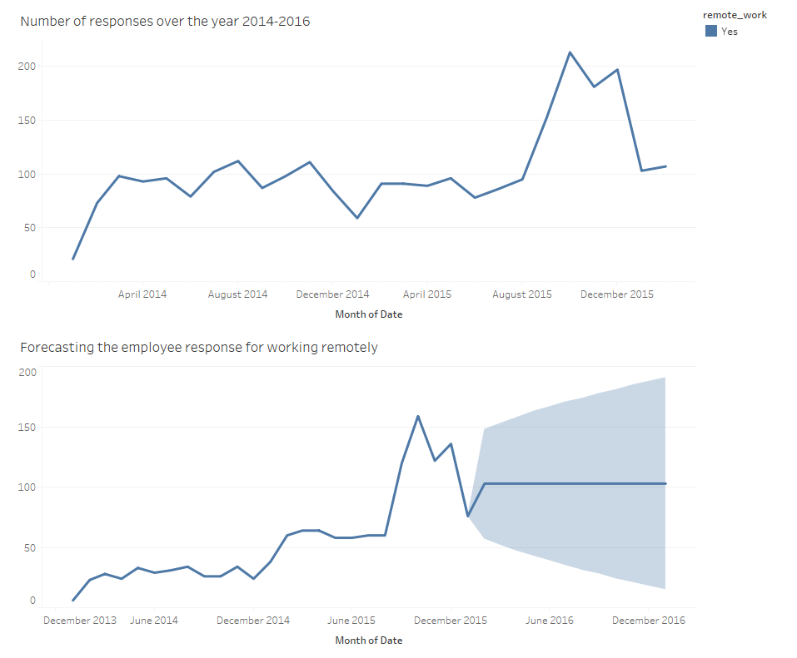

From the above dashboard, we see that the number of survey participants has increased over the years as seen in the first sheet. As we can see in the second sheet, the number of people willing to work remotely has also increased over the years, and when forecasted, we see that smoothing has been performed. This is due to the irregular patterns in the data. Also, as seen in our informative dashboards, people with mental disorder prefer working remotely.

**OVERALL INSIGHTS**

* 40% of the participants are currently suffering from mental disorder.
* 60% of the participants are taking treatment for mental disorder.
* Most of the employees suffering from mental disorder have family history of mental illness.
* Many employees suffering from mental disorder are not aware of the benefits provided by the companies.
* Mental disorder is high in employees working in small companies.
* Most of the employees feel comfortable sharing their mental issue with their friends and family than sharing with their co-workers or supervisors.
* Many employees suffering from mental disorder feel it is easy to get leave approval.
* Also, majority of the people suffering from mental illness are not sure about companies protecting their identity in case of confessing about mental health problem.
* Participants suffering from mental disorder also feel this might impact their productivity and have negative consequences when discussed with the potential employer.
* Another noticeable insight is that mental disorder is more concentrated in people with age group 20-50

**ACTIONABLE INSIGHTS**

* Companies could learn about the employee’s family history of illness in advance at the time of interview or at the time of counselling and ensure these employees are compulsorily made to attend the sessions/training related to overcoming mental illness.
* Conduct seminars to acquaint them with the policies of the company and to spread awareness of the benefits provided by the company for employees suffering from mental illness.
* Since we see mental illness is more common in small companies, companies could hire more number of employees to reduce work pressure which eventually prevents the employees from experiencing mental stress.
* Ample amount of resources should be created and made available to all the employees of the company to understand the benefits and the way their identity will be preserved in case of suffering from mental illness.
* Companies could provide mental health insurance if their budget permits and can have dedicate number of leaves for employees experiencing mental stress and employees under treatment for mental illness.
* Regular counselling session could help employees relieve from mental disorder problem.